NATIONAL UNIVERSITY OF COMPUTER AND EMERGING SCIENCES

(KARACHI CAMPUS)

Department of Computer Science

**Fall 2019**

Fast

12/13/2019

Computer Organization and Assembly Language

GroupMembers*:*

[Ovaiz Ali]         - [18K-0137]

[Zaeem Ahmed] - [18K-0166]

[Mubasher Ansari] - [18K-1053]

Section*:* CS-A

Identifying Expressions of Emotion in Text

Project Report

* ***Introduction:***
* List of seed words are prepared for six basic emotion categories proposed by Ekman. These categories represent the distinctly identifiable facial expressions of emotion – **happiness, sadness, anger, disgust, surprise and fear.**
* **Keyword-based Methods** are used in this project.
* Keywords based approaches use synonyms and antonyms are WordNet to determine word sentiments based on a set of seed opinion words.
* WordNet to predict the semantic orientation of adjective.
* As all the adjectives are linked and it form a pattern and leads to the emotion which the word depict.
* ***Working methodology and Importance of the Project:***

1. Project is totally based on assembly language, and all the workings are in VS 2017.
2. Identifying expression can be used in any sort of application and browser for human interaction.
3. Human behavior and attributes can be easily detected by the respective medium.
4. Modeling user behavior based on the first dataset (first month dataset). We applied our approach to our first dataset and build human behavior model/profile.

* ***Commands And Features :***

The commands, keywords and features of Assembly language x86 which are used in this Project, some are listed below;

1. Macros
2. Filing (Read/Write)
3. 2d Arrays
4. String primitives
5. Proto, Invoke ,Proc commands
6. Stack frames
7. Multiple Functions
8. Comparisons
9. Procedures in Irvine32 Library
10. Flags

* ***Difficulties Faced:***

1. In string comparison, after finding a word from file, string find pointer should got to top of the file.
2. Storing string in an array, because if the length of new string is smaller than the char of previous one's remain stored in an array.
3. Splitting the input sentence into words and storing it in new file of named Input.
4. Also faced the difficulty in counting the emotions.
5. Figuring out mixed emotions.

* ***Improvements:***

1. We improved the string find and string comparison which was our main problem.
2. If there is no emotion type word in sentence, then a message will be displayed.
3. Input string stored successfully in a file.
4. We made our project easily understandable and readable to any one by commenting the things which we are doing,
5. Multiple function calls and their proto has been used to remove complexity.

* ***File names:***

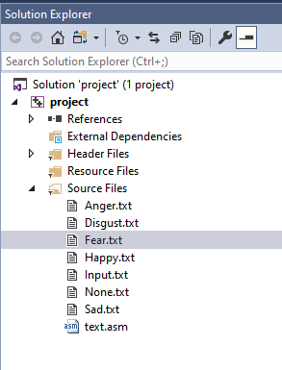

* ***System Diagrams, Flow Charts:***

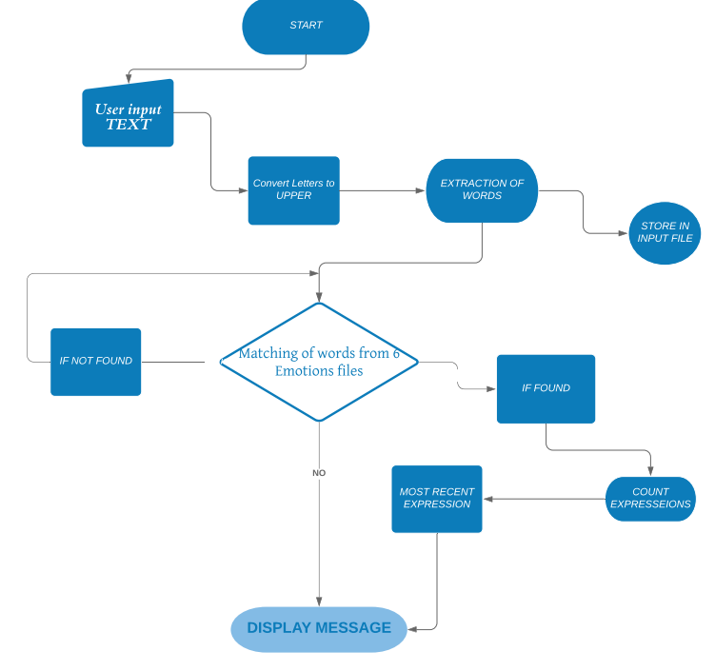

* ***Some working code (prominent procedures):***

1. Extracted_Word PROC:

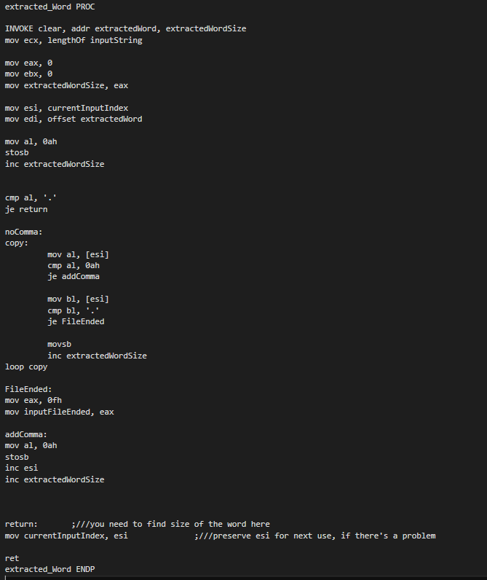

1. wordFind PROC:

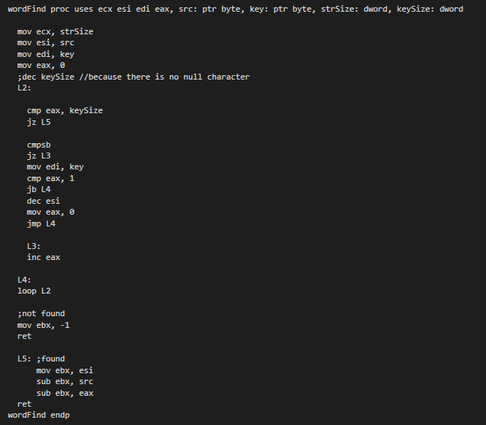

1. countEmotions PROC:

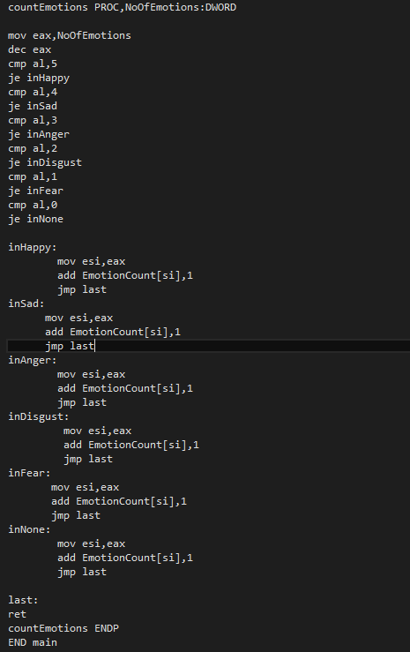

* ***ScreenShots:***

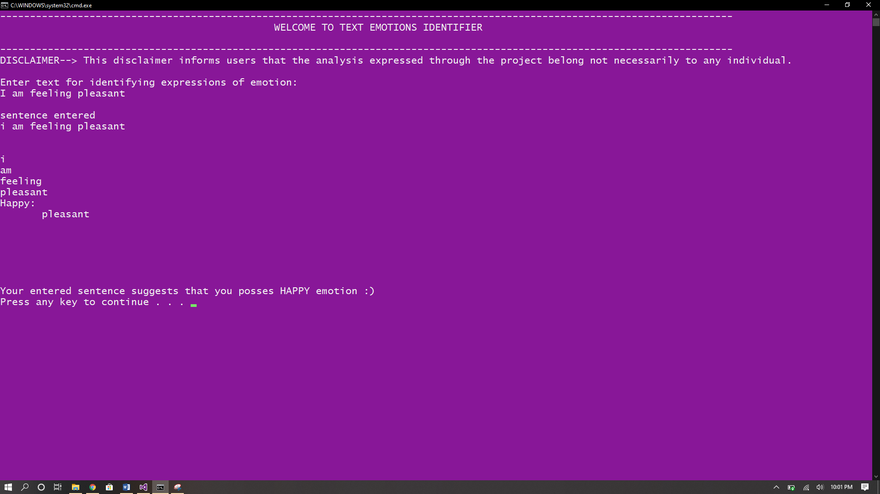

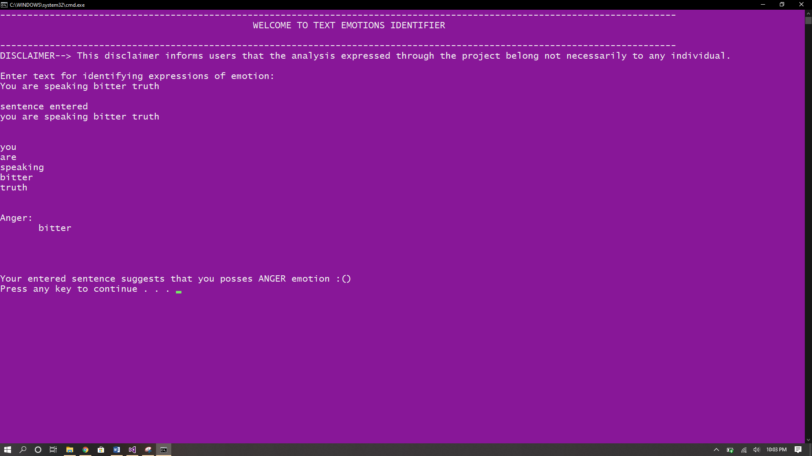

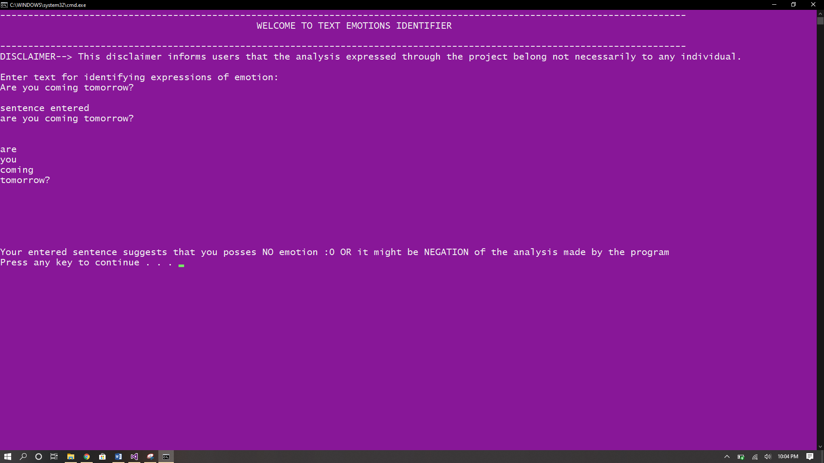

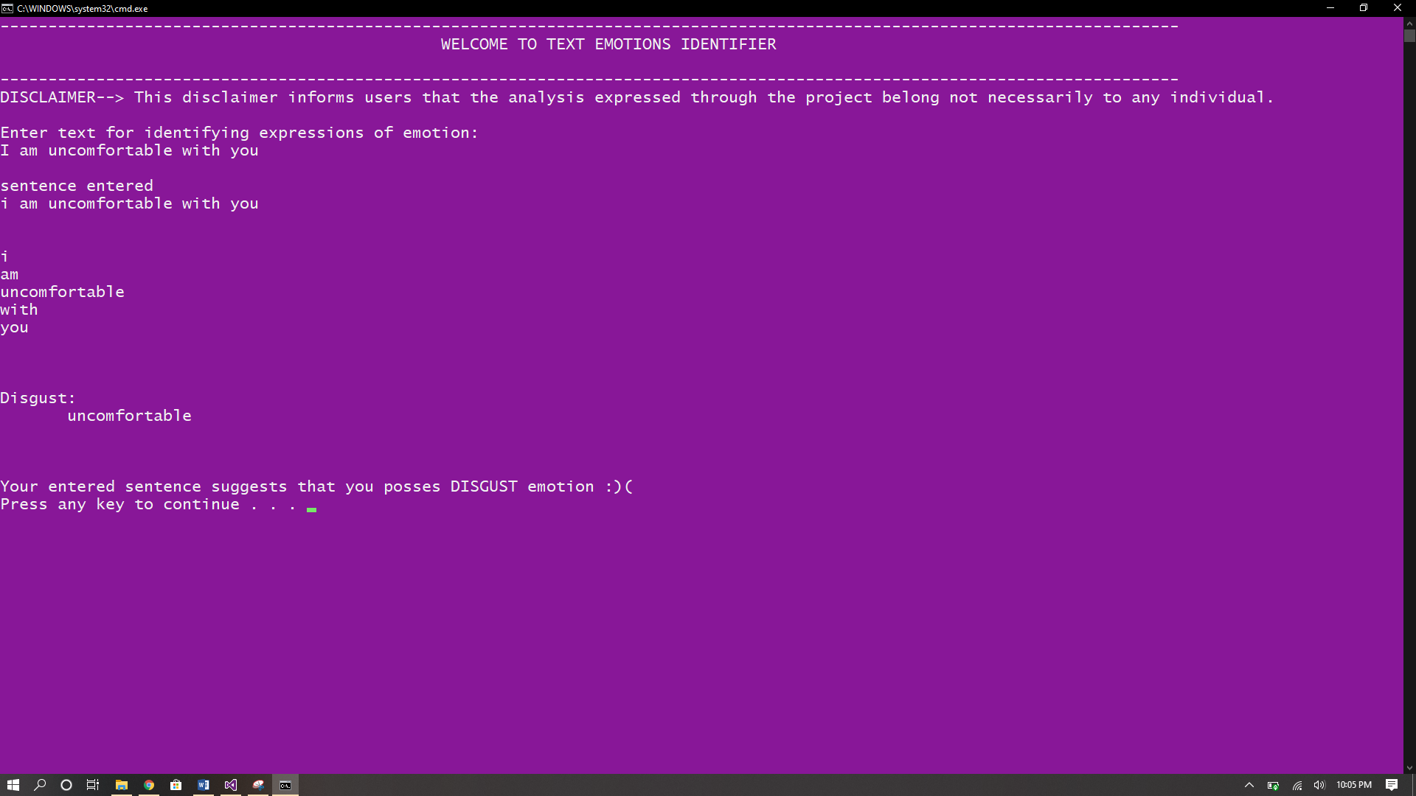

* ***Conclusion:***

With keeping the need of the projects based on the pnemenon of NLP this project is essential for futher working in future to improve it with more data sets and can be embedded into modren day programs either to find out views of the customers or processing intentions of the writer through text.